**Business Report**

**Project –SMDM**

**Created by Amit Jain**

Table of Contents

**1.** **Wholesale Customers Analysis** 4

**1.1** **Use methods of descriptive statistics to summarize data. Which Region and which Channel spent the most? Which Region and which Channel spent the least?** 5

**1.2** **There are 6 different varieties of items that are considered. Describe and comment/explain all the varieties across Region and Channel? Provide a detailed justification for your answer.** 7

**1.3** **On the basis of a descriptive measure of variability, which item shows the most inconsistent behaviour? Which items show the least inconsistent behaviour?** 11

**1.4** **Are there any outliers in the data? Back up your answer with a suitable plot/technique with the help of detailed comments.** 12

**1.5** **On the basis of your analysis, what are your recommendations for the business? How can your analysis help the business to solve its problem?**

**2.** **CMSU Student Analysis** 14

**2.1** **For this data, construct the following contingency tables (Keep Gender as row variable)** 15

**2.1.1** **Gender and Major Solution:** 15

**2.1.2** **Gender and Grad Intention** 15

**2.1.3** **Gender and Employment** 15

**2.1.4** **Gender and Computer** 15

**2.2** **Assume that the sample is representative of the population of CMSU. Based on the data, answer the following question:** 16

**2.2.1** **What is the probability that a randomly selected CMSU student will be male?** 16

**2.2.2** **What is the probability that a randomly selected CMSU student will be female?** 16

**2.3** **Assume that the sample is representative of the population of CMSU. Based on the data, answer the following question:** 17

**2.3.1** **Find the conditional probability of different majors among the male students in CMSU.** 17

**2.3.2** **Find the conditional probability of different majors among the female students of CMSU.** 18

**2.4** **Assume that the sample is a representative of the population of CMSU. Based on the data, answer the following question:** 19

**2.4.1** **Find the probability That a randomly chosen student is a male and intends to graduate.** 19

**2.4.2** **Find the probability that a randomly selected student is a female and does NOT have a laptop.** 19

**2.5** **Assume that the sample is a representative of the population of CMSU. Based on the data, answer the following question:** 20

**2.5.1** **Find the probability that a randomly chosen student is a male or has a full-time employment** 20

**2.5.2** **Find the conditional probability that given a female student is randomly chosen, she is majoring in international business or management** 20

**2.6** **Construct a contingency table of Gender and Intent to Graduate at 2 levels (Yes/No). The Undecided students are not considered now and the table is a 2x2 table. Do you think graduate intention and being female are independent events?** 21

**2.7** **Note that there are four numerical (continuous) variables in the data set, GPA, Salary, Spending and Text Messages. Answer the following questions based on the data** 21

**2.7.1** **If a student is chosen randomly, what is the probability that his/her GPA is less than 3?** 21

**2.7.2** **Find conditional probability that a randomly selected male earns 50 or more. Find conditional probability that a randomly selected female earns 50 or more.** 21

**2.8** **Note that there are four numerical (continuous) variables in the data set, GPA, Salary, Spending and Text Messages. For each of them comment whether they follow a normal distribution.** 22

**3.** **Manufacturers of ABC Asphalt** 24

**3.1** **Do you think there is evidence that means moisture contents in both types of shingles are within the permissible limits? State your conclusions clearly showing all steps.** 26

Check for Shingle A 26

Check for Shingle B 26

**3.2** **Do you think that the population mean for shingles A and B are equal? Form the hypothesis and conduct the test of the hypothesis. What assumption do you need to check before the test for equality of means is performed?** 27

# **Wholesale Customers Analysis**

**Problem Statement:**

A wholesale distributor operating in different regions of Portugal has information on annual spending of several items in their stores across different regions and channels. The data consists of 440 large retailers’ annual spending on 6 different varieties of products in 3 different regions (Lisbon, Oporto, Other) and across different sales channel (Hotel, Retail).

Introduction: This report explains the business requirements and provide the detailed solution based on the data provided for each problem statement. given in the assignment.

Step of understanding the data:

* Import the data: Imported the data using Python notebooks and analyzed the Channel and Region by spending amount for each Product category.

This is how the data look like:

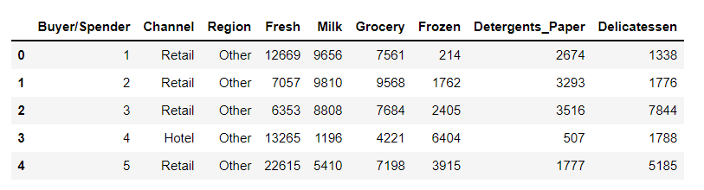

# **Use methods of descriptive statistics to summarize data. Which Region and which Channel spent the most? Which Region and which Channel spent the least?**

Solution: Based on analysis of the data, we Grouped the data for Channel wise and then Region wise and checked the total amount spent for all the products and generated the Bar Chart/Following are the Bar Chart Channel wise and region wise along with the data:

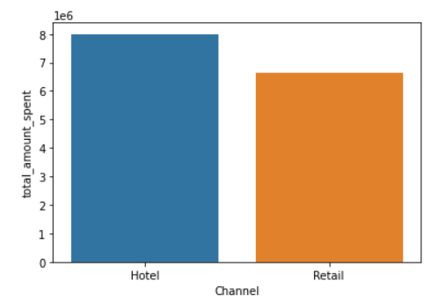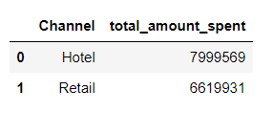

We can clearly see that Channel wise Hotel segment has Spent more than Retails Channel.

Hotel channel spend amount is $7999569 with the highest spend amount and,

Retail spend amount $6619931 has least spend amount based on Channel.

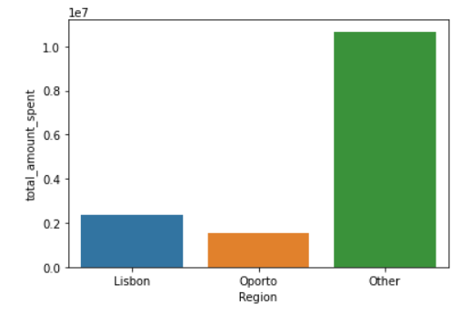Similarly, Following are the bar plots for Region wise data set:

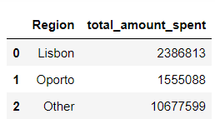

We can clearly see that Region wise Regions in Other segment has Spent most and Oporto spent least amount of money in total product category

Other regions spend amount is $10677599 with the highest spend amount and Oporto region spend amount is $ 1555088 and has least spend amount by Region.

# **There are 6 different varieties of items that are considered. Describe and comment/explain all the varieties across Region and Channel? Provide a detailed justification for your answer.**

Warehouse data is the combination of 2 Channels (Hotel and Retail), gathered from 3 segment of Regions (Lisbon, Oporto, and Other regions) also it shows Amount spent by each customer in following 6 categories of products:

| Fresh | Milk | Grocery | Frozen | Detergents Paper | Delicatessen | total_amount_spent |
| --- | --- | --- | --- | --- | --- | --- |

Based on the analysis of the all categories of the product, we Grouped data for Channel wise and taken the summation of total amount spent on each product line. Following numbers and plotted in a bar chart when we arranged data Channel wise:

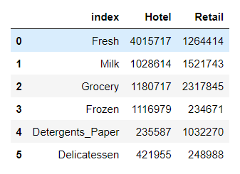

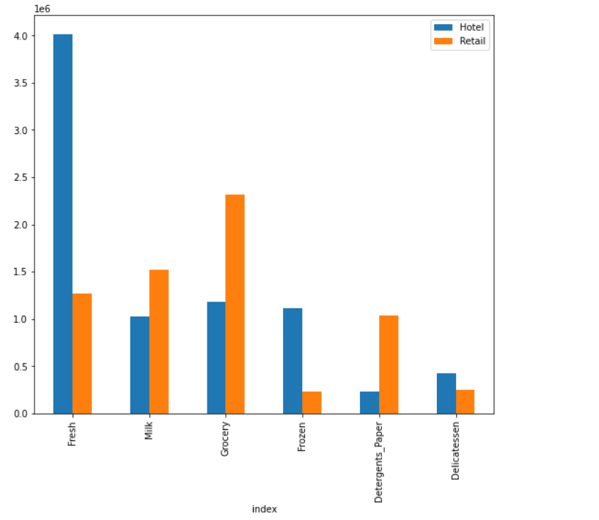

#### From Above graph we can see that "Hotel" has spent most of the amount in "Fresh" product and least in "Detergents Paper"

#### And "Retail" has spent most of the amount in "Grocery" product and least in "Frozen"

Based on the analysis of the all categories of the product, we Grouped data for Region wise and taken the summation of total amount spent on each product line. Following numbers and plotted in a bar chart when we arranged data Region wise:

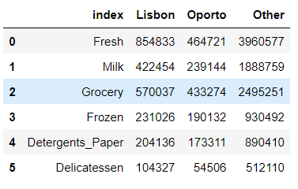

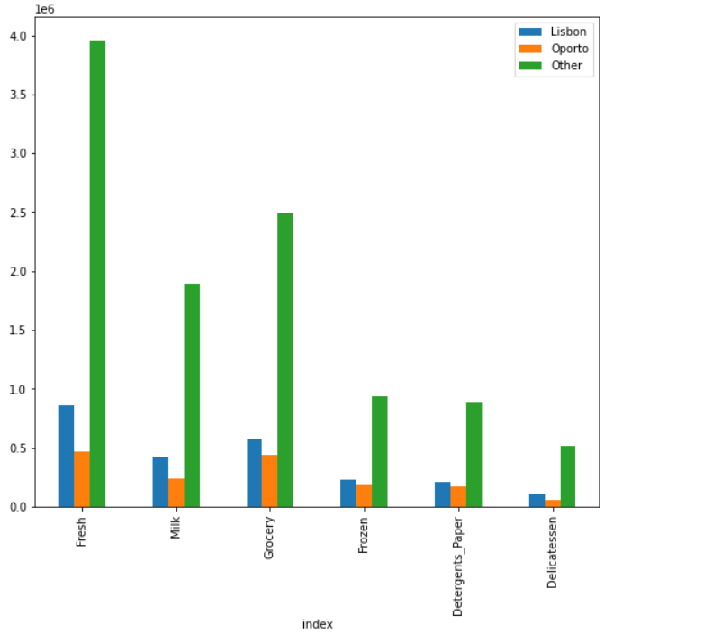

#### From Above graph we can see that "Lisbon" has spent most of the amount in "Fresh" product and least in "Delicatessen"

#### And "Oporto" has spent most of the amount in "Fresh" product and least in "Delicatessen"

#### On the other hand, regions in "Other" Categories has spent most of the total amount in "Fresh" product and least in "Delicatessen"

# **Based on a descriptive measure of variability, which item shows the most inconsistent behavior? Which items show the least inconsistent behavior?**

Solution: Using Coefficient of Variation we find out the least value is of Category “Fresh” (1.05) and highest value is of Category “Delicatessen” (1.85) So from the given data it is clear that most inconsistent behavior shown by item – Delicatessen And least inconsistent behavior shown by item – Fresh

Below is the output from Python –

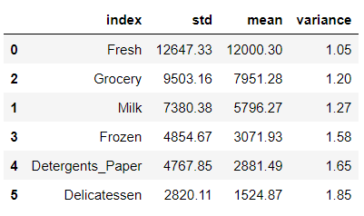

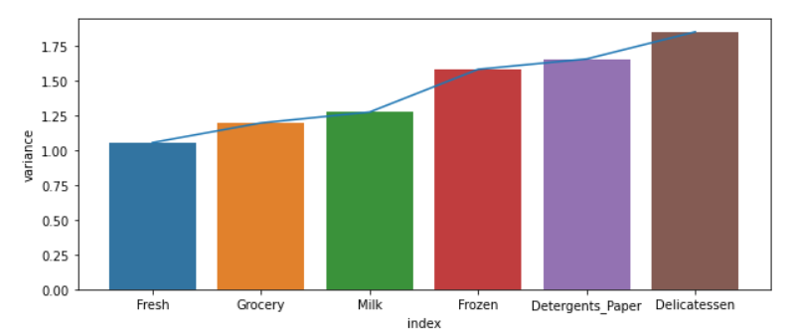

# **Are there any outliers in the data? Back up your answer with a suitable plot/technique with the help of detailed comments.**

We plotted boxplot and the output gives the details that in all the data there are outliers:

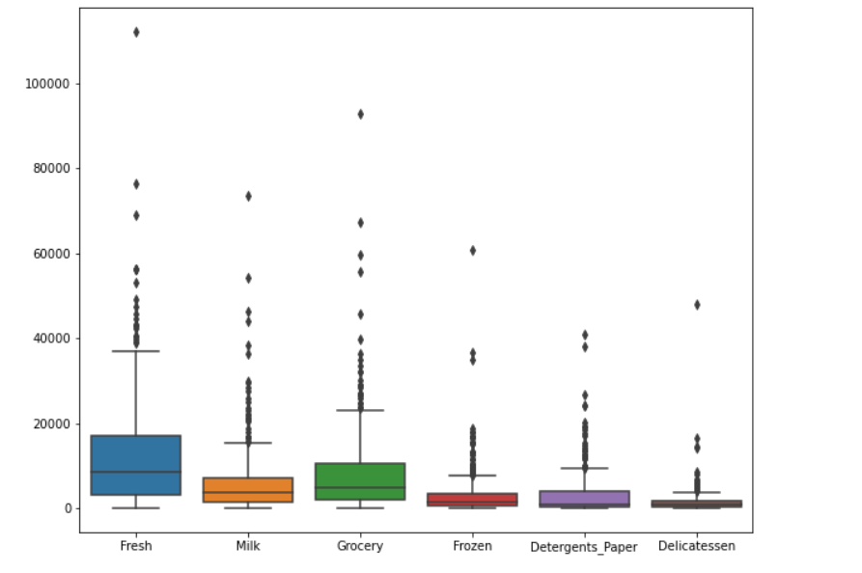

# **Based on your analysis, what are your recommendations for the business? How can your analysis help the business to solve its problem? Answer from the business perspective**

### Answer Since we do not have enough data available in data source, example: profit or loss information, we cannot judge if spending more money on which product is good for the business or if it is not a profitable product then minimize the Spending on that product.

### But still If we ASSUME that profits are same in ratio for all the products , and based on variance in above chart we can suggest that Spending behavior has lot of variations in Product "Delicatessen" so amount spend should be equally distributed in all of the products, to foreseen the future market.

# **CMSU Student Analysis**

## The Student News Service at Clear Mountain State University (CMSU) has decided to gather data about the undergraduate students that attend CMSU. CMSU creates and distributes a survey of 14 questions and receives responses from 62 undergraduates (stored in the Survey data set).

Step of understanding the data:

* Import the data: Imported the data using Python notebooks and analyzed the Student records for CMSU university.

This is how the data look like:

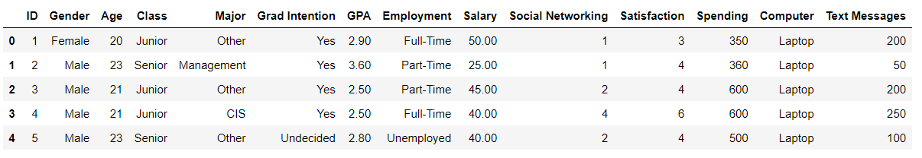

# **For this data, construct the following contingency tables (Keep Gender as row variable)**

# **Gender and Major Solution:**

Below is the contingency table for Gender and Majors

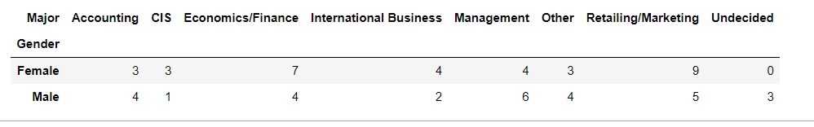

# **Gender and Grad Intention**

Below is the contingency table for Gender and Graduation Intention:

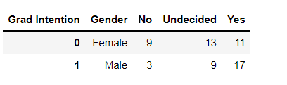

# **Gender and Employment**

Below is the contingency table for Gender and Employment:

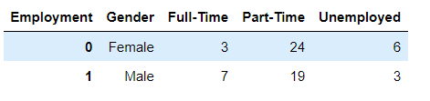

# **Gender and Computer**

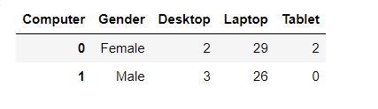

# **Assume that the sample is representative of the population of CMSU. Based on the data, answer the following question:**

# **What is the probability that a randomly selected CMSU student will be male?**

For this we need to find out total male students out of whole student from the given data. The probability that a random selected CMSU student will be a male is: 47%

# **What is the probability that a randomly selected CMSU student will be female?**

For this we need to find out total Female students out of whole student from the given data. The probability that a random selected CMSU student will be a female is: 53%

# **Assume that the sample is representative of the population of CMSU. Based on the data, answer the following question:**

# **Find the conditional probability of different majors among the male students in CMSU.**

The probability that a random selected CMSU Male student taking Accounting as a major is

13.79%

Solution: Using contingency tables of Gender and Majors we got the total numbers of males and number of males opting for different majors Below is the output from Python –

The probability that a random selected CMSU Male student taking Accounting as a major is

13.79%

The probability that a random selected CMSU Male student taking CIS as a major is 3.4%

The probability that a random selected CMSU Male student taking International Business as a major 6.89%

The probability that a random selected CMSU Male student taking Management as a major is

20.68%

The probability that a random selected CMSU Male student taking Other as a major is 13.79%

The probability that a random selected CMSU Male student taking Retailing/Marketing as a major is 17.24%

The probability that a random selected CMSU Male student and not yet Decided for any major is 10.3%

# **Find the conditional probability of different majors among the female students of CMSU.**

Solution: Using contingency tables of Gender and Majors we got the total numbers of females and number of females opting for different majors Below is the output from Python –

The probability that a random selected CMSU Female student taking Accounting as a major is 9.1%

The probability that a random selected CMSU Female student taking CIS as a major is 3.03%

The probability that a random selected CMSU Female student taking Economics/Finance as a major is 21.21%

The probability that a random selected CMSU Female student taking International Business as a major is 12.12%

The probability that a random selected CMSU Female student taking Management as a major is

12.12%

The probability that a random selected CMSU Female student taking Other as a major is 9.1%

The probability that a random selected CMSU Female student and not yet Decided for any major is 0%

# **Assume that the sample is a representative of the population of CMSU. Based on the data, answer the following question:**

# **Find the probability That a randomly chosen student is a male and intends to graduate.**

Solution: Using contingency tables of Gender and Grad Intention we got the total numbers of males and number of males intends to be graduate And post calculation we find out that - The probability That a randomly chosen student is a male and intends to graduate is 58.62%

# **Find the probability that a randomly selected student is a female and does NOT have a laptop.**

Solution: Using contingency tables of Gender and Computer we got the total numbers of females and number of females does not have a laptop And post calculation we find out that The probability That a randomly chosen student is a Female and Don’t have Laptop is 12.12%

# **Assume that the sample is a representative of the population of CMSU. Based on the data, answer the following question:**

# **Find the probability that a randomly chosen student is a male or has a full-time employment**

Solution: Using contingency tables of Gender and Employment we got the total numbers of males and number of males who are full time employed And post calculation we find out that - The probability of randomly chosen student is a male or has a full-time employment is 51.61%

# **Find the conditional probability that given a female student is randomly chosen, she is majoring in international business or management**

Solution: Using contingency tables of Gender and Major we got the total numbers of females and number of females majoring in international business or management. And post calculation we find out that - The probability of randomly chosen student is a Female and she is majoring in international business or management is 24.24%

# **Construct a contingency table of Gender and Intent to Graduate at 2 levels (Yes/No). The Undecided students are not considered now, and the table is a 2x2 table. Do you think graduate intention and being female are independent events?**

Solution: We call Events as independent when their probabilities are not equal, hence from above result we can say that Being Female and graduate intention is not dependent

Probability of graduate intention is 70%

Probability of graduate intention being female is 55%

# **Note that there are four numerical (continuous) variables in the data set, GPA, Salary, Spending and Text Messages. Answer the following questions based on the data**

# **If a student is chosen randomly, what is the probability that his/her GPA is less than 3?**

Solution: We first checked how many students have GPA less than 3 and then taken probability for those Students getting less than 3 GPA based on the data:

Probability that if a student is chosen randomly his/her GPA is less than 3 is 27.42%

# **Find conditional probability that a randomly selected male earns 50 or more. Find conditional probability that a randomly selected female earns 50 or more.**

Solution: We first checked how many Female students are present and their Count for how many Female earns more than 50 Salary:

Probability that if randomly selected male earns 50 or more is 34.48%

# **Note that there are four numerical (continuous) variables in the data set, GPA, Salary, Spending and Text Messages. For each of them comment whether they follow a normal distribution.**

Based on distribution of the data for GPA, Salary, Spending and Text Messages, we plotted displot as well as QQ Plot, we can check that there is no relation between data for Spending and Text Messages , whereas GPA and Salary is following a pattern and data is distributed on a bell curve, which denotes that data for GPA and Spending is Normal distributed, whereas Text messages and salary data is not distributed Normally.

Graphs for the data are shows below:

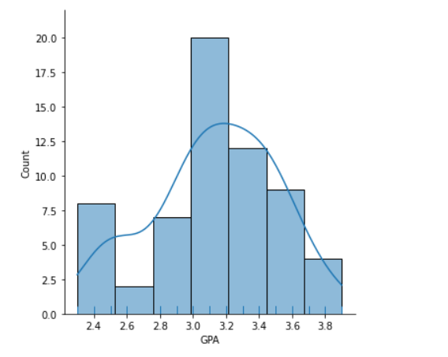 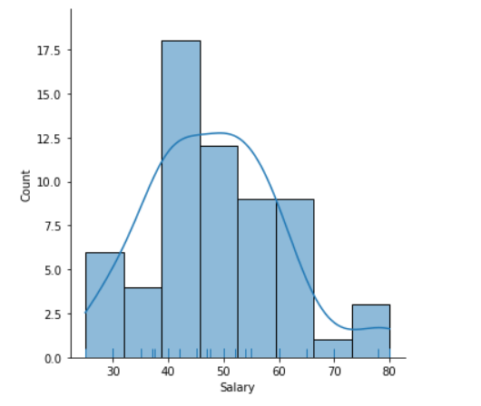

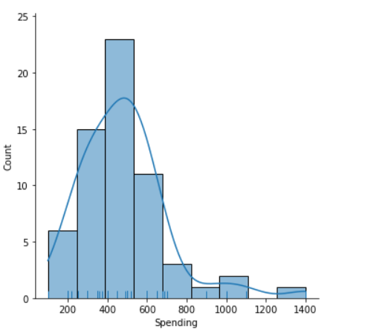 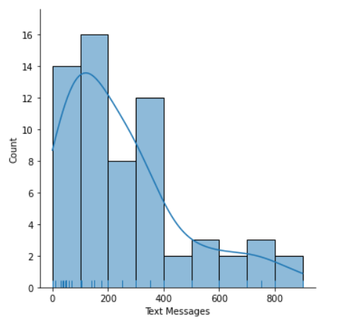

QQ Plots for the data are as follows:

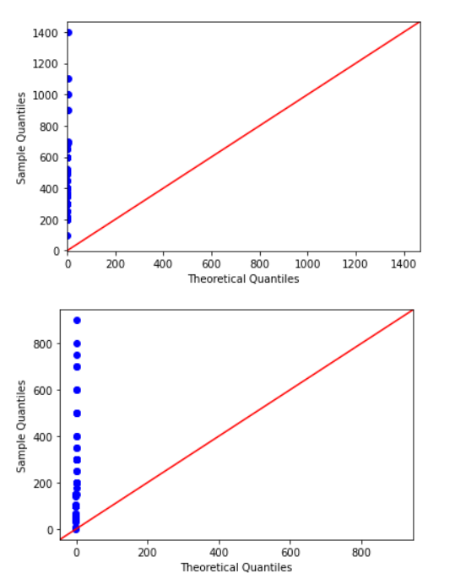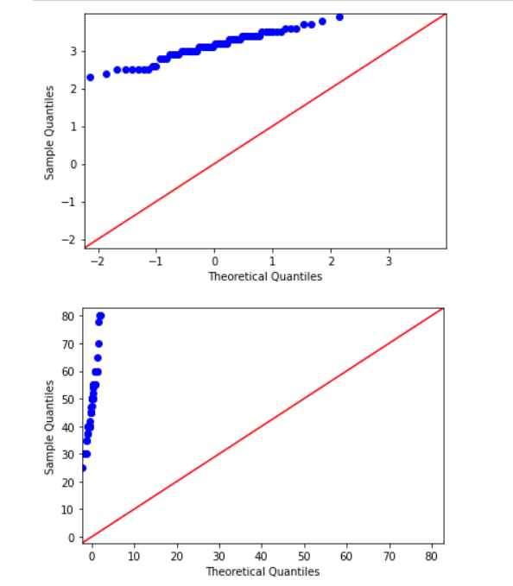

### Based on the Dist Plot and QQ Plot, we can see that GPA and salary are normally distributed but spending and Text messages are not normally distributed

# **Manufacturers of ABC Asphalt**

## An important quality characteristic used by the manufacturers of ABC asphalt shingles is the amount of moisture the shingles contain when they are packaged. Customers may feel that they have purchased a product lacking in quality if they find moisture and wet shingles inside the packaging. In some cases, excessive moisture can cause the granules attached to the shingles for texture and coloring purposes to fall off the shingles resulting in appearance problems. To monitor the amount of moisture present, the company conducts moisture tests. A shingle is weighed and then dried. The shingle is then reweighed and based on the amount of moisture taken out of the product, the pounds of moisture per 100 square feet are calculated. The company would like to show that the mean moisture content is less than 0.35 pounds per 100 square feet.[¶](http://localhost:8888/notebooks/Desktop/PGP-DSBA/Month_2_Project/AmitJain_20_March_2022.ipynb#An-important-quality-characteristic-used-by-the-manufacturers-of-ABC-asphalt-shingles-is-the-amount-of-moisture-the-shingles-contain-when-they-are-packaged.-Customers-may-feel-that-they-have-purchased-a-product-lacking-in-quality-if-they-find-moisture-and-wet-shingles-inside-the-packaging.---In-some-cases,-excessive-moisture-can-cause-the-granules-attached-to-the-shingles-for-texture-and-coloring-purposes-to-fall-off-the-shingles-resulting-in-appearance-problems.-To-monitor-the-amount-of-moisture-present,-the-company-conducts-moisture-tests.-A-shingle-is-weighed-and-then-dried.-The-shingle-is-then-reweighed,-and-based-on-the-amount-of-moisture-taken-out-of-the-product,-the-pounds-of-moisture-per-100-square-feet-are-calculated.-The-company-would-like-to-show-that-the-mean-moisture-content-is-less-than-0.35-pounds-per-100-square-feet.)

## The file (A & B shingles.csv) includes 36 measurements (in pounds per 100 square feet) for A shingles and 31 for B shingles.

First, we Loaded the data using Python: This is how the data look like:

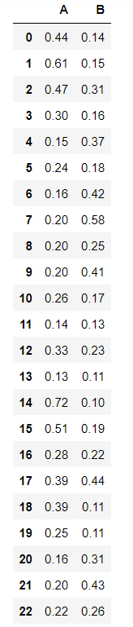 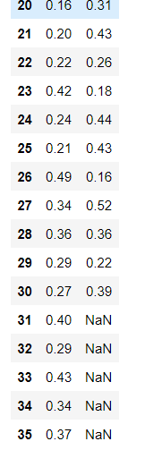

We can see that total number of samples for Shingle A and B are different , also there is no relation between both data sets, and both can be treated indivisually.

# **Do you think there is evidence that means moisture contents in both types of shingles are within the permissible limits? State your conclusions clearly showing all steps.**

Declare Null and Alternate Hypothesis

Ho= moisture contents >= 0.35

Ha= moisture contents < 0.35

## Check for Shingle A

We analyzed the sample records based on Shingle A samples and calculated the P_VALUE for Shingle A samples.

One sample t test

t statistic: -1.4735046253382782 p value: 0.07477633144907513

Assuming that Alpha value is 0.05

When actual_p_value < alpha_value:

Based on the rule:

When actual_p_value < Level of significance then We get evidence to reject the null hypothesis.

When actual_p_value > Level of significance then we consider that there is no evidence to reject the null Hypothesis.

And based on above data set, we can say that

We have no evidence to reject the null hypothesis since actual_p_value > Level of significance

Our one-sample t-test p-value= 0.07477633144907513

Null Hypothesis is True, it means Moisture content is Greater than 0.35

## Check for Shingle B

We need to remove NULL values for Shingle B Sample data set, and then we can calculate the pvalue for Shingle B Samples. Upon calculations, we found that

We have evidence to reject the null hypothesis since p value < Level of significance

Our one-sample t-test p-value= 0.0020904774003191813

Alternate Hypothesis is True, it means Moisture content is Less than 0.35

# **Do you think that the population mean for shingles A and B are equal? Form the hypothesis and conduct the test of the hypothesis. What assumption do you need to check before the test for equality of means is performed?**

Solution: Generate the NULL and Alternate hypothesis.

Ho= meanA = meanB

Ha= meanA != meanB

Since this time, we need to calculate comparative analysis of independent data then we will use 2 sample T test

Upon calculations, we found that tstat 1.2896282719661123

And P Value 0.2017496571835306

Based on the rule as mentioned above, we can say that We have no evidence to reject the null hypothesis since p value > Level of significance

Our one-sample t-test p-value= 0.0020904774003191813

,which means with 95% confidence we can say that mean for both shingles A and B will be same